**1. Git-HOL**

CODE

$git --version

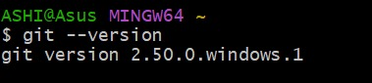

# Create folder and navigate into it

$mkdir GitDemo

$cd GitDemo

# Initialize Git

$git init

# Configure Git (only first time on your machine)

$git config --global user.name "Your Name"

$git config --global user.email [your-email@example.com](mailto:your-email@example.com)

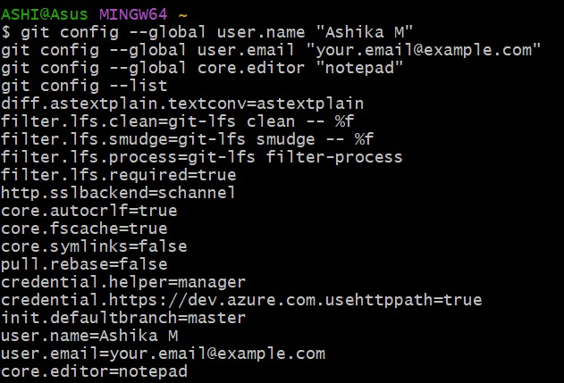

# Create a file

$echo "Welcome to Git" > welcome.txt

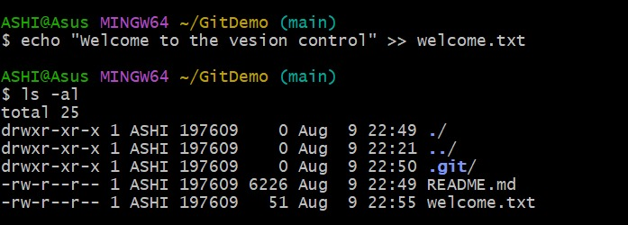

# Add file to staging

$git add welcome.txt

# Commit changes

$git commit -m "Initial commit"

# Add remote repository (replace with your GitLab repo URL)

$git remote add origin https://gitlab.com/ashikam22cs-group/GitDemo.git

# Change branch name to master

$git branch -m main master

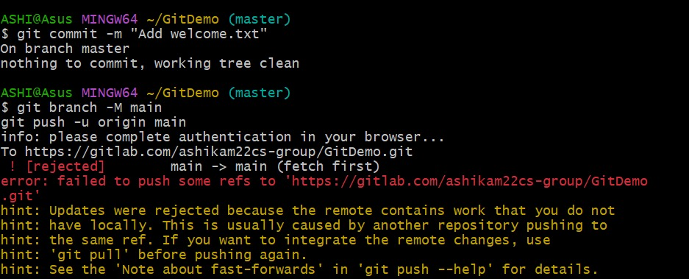

# Push to remote

$git push -u origin master --force

# Pull from remote

$git pull origin master

#Push again if needed

$git push origin master

$ls-al

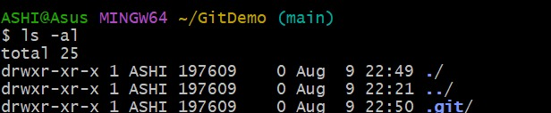

IN GITLAB

